**Online Diary – Revitalising Noughts and Crosses**

Groups Members – Connor Winspur, Cory Arnett-O’Brien, Ngozi Egonu, Akash Sroay.

Player Testers - Jessica Evans, Hou Yap, Joshua Baker, Zakaria Ahmed.

1. **- Overview and Game Description**

The team was tasked with revitalising the classic skill-based game of noughts and crosses by adding a chance-based element to the game, while making sure that it still resembled the original game. To achieve this the team decided that a die would be utilised to decide the actions the players can take during their turn, in addition to reversing the goal, making it so the players had to use the actions they are given to force their opponent to achieve a five in a row on the provided board.

**3.1 – Materials**

In order to achieve this, the team used the software Construct 3 to make a simple web-based board for the game. This simple game featured the board, the die roll and functionality that allowed the player to place their shapes and also remove them from the board, which can all be seen in Figure 3.1.

**3.2 – Rules and Mechanics**

Players roll a die to decide who goes first, the highest number gets to decide if they go first or second.

Players place one of their respective shapes in a space on the board before the game starts.

At the start of each turn the players roll the die to decide on what action they take.

* Rolling a 1 or 2 - Allows the player to place their respective shape (either a nought or a cross).
* Rolling a 3 - Remove one of your own shapes.
* Rolling a 4 - Swap your shapes place with one of the other players.
* Rolling a 5 - Miss your turn.
* Rolling a 6 - Place a shape for the other player.

Players must always have one shape on the board at all times. If they roll a 3 at this time, they skip their turn.

The winner is the player that forces their opponent to complete a line of 5 in any direction.

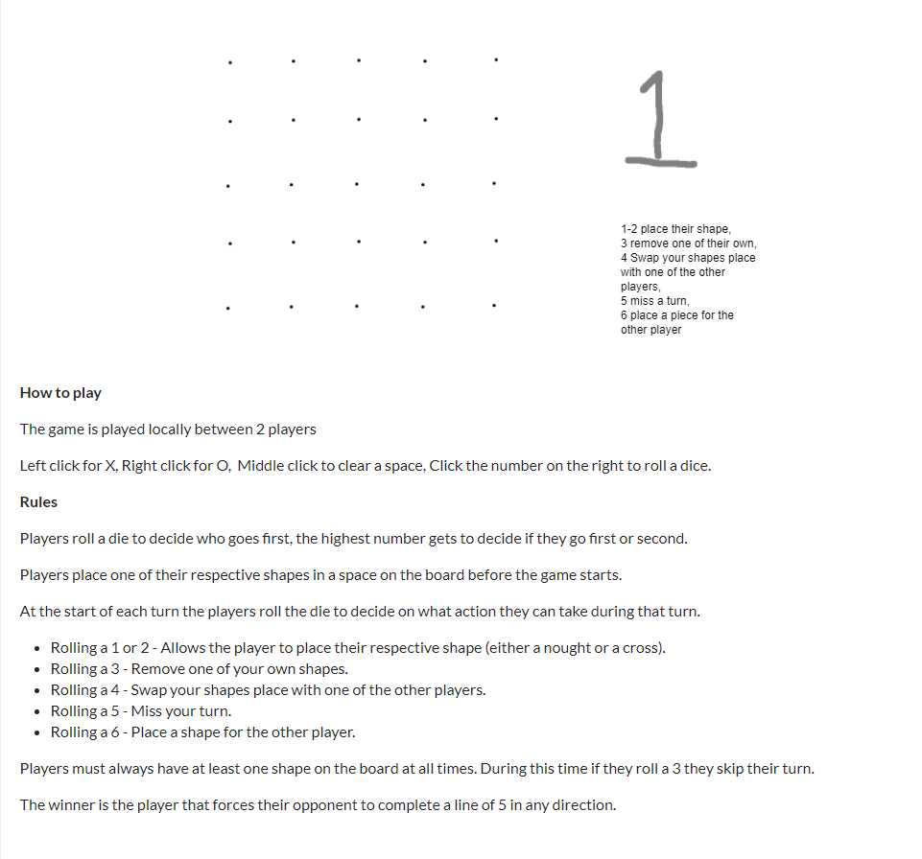

[A]

[B]

[C]

[D]

**Figure 3.1. Completed Game Page –** The scene shown in this figure the completed webpage for the game with [A] showing the 5 x 5 board, [B] showing the inbuilt die roll, [C] displaying the functionality that was added to allow the players to interact appropriately with the game and finally [D]representing a full layout of the rules for players to see, which is marked.

**3.3 – Play Testing**

During this session the team was able to utilise both internal and external play testing.

During the internal playtesting the following issues were encountered;

* Could not remove shapes on the board.
* Able to play out of turn.
* The game does not let you know who has won.
* The rules were not clearly defined for players to see.

In order to fix these issues after the initial playtesting the ability to clear a space on the board was added and the game page was reworked to make it easier to understand, while adding the rules to it.

During the external playtesting the players brought up;

* The games lasted to long and to make the board smaller to fix this.
* The game was easy to learn.

**3.4 – Experience and Skills Learnt**

During this project the team defined a clear idea to follow and delegated tasks in order to meet the time requirements. However, the team was still inexperienced with playtesting, which meant it consumed a lot of time, preventing to much progress being made from the information that was received back.